HW1 -Part 7 Report

Write a .bat (for Windows) or .sh (for MacOS) to import the entire NYSE dataset (stocks A to Z) into MongoDB. NYSE Dataset Link: http://msis.neu.edu/nyse/nyse.zip

1. **Create a mymongo.sh file by vim**

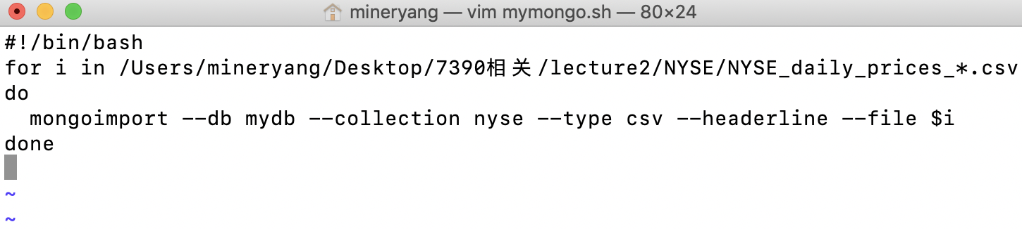

1. **Execute the batch file by using bash mymongo.sh**

1. **Check the MongoDB**



